Women’s Shoe Store Performance Dashboard
Data Model Documentation(2024)

Prepared by Ramsheena

—--------------------------------------------------------------------------------------------------------------------------

1.Tables Overview

1.sales (Fact table)
Key columns:
- Sale_id
- Branch_id
- Shoe_id
- Sales_date
- Quantity_sold
- Total_price
Purpose:
This is the central fact table and the core engine of the data model.It stores all transactional sales records and is used to calculate key KPIs such as:
- Total Sales Revenue
- Total Units Sold
- Sales by Branch
- Total Orders
All dimension tables connect directly or indirectly to this table.
2. Branches (Dimension table)
Key columns:
- Branch_id
- Branch_name
- City
- Manager_name
Purpose:
This table Provides descriptive attributes (name, city, manager) to give business context to raw sales transactions. It enables detailed analysis such as:
- Branch Performance
- Regional/City Analysis
- Manager Accountability
- Branch Growth Trends
Connected to sales via branche_id.
3.Shoes (Dimension table)
Key columns:
- Shoe_id
- Category
- Color
- Size
- Price
Purpose:
This table provides product-level segmentation and analysis across categories, colors, sizes, and price ranges. It enables detailed analysis such as:
- Category Performance
- Color & Size Preferences
- Product Contribution
- Inventory & Demand Planning
Connected to sales via shoe_id.

4.Sales_targets (dimension table)
Key columns:
- Branch_id
- Month
- Sales_target
- Unit_target

Purpose:
Stores planned or expected performance values (targets) for each branch and month.It enables detailed analysis such as:
- Target Achievement
- Variance Analysis
- Strategic Insights
- Branch Performance vs. Goals

Connected indirectly to sales via branch_id. It is a specialized dimension table that is connected to the branches table.

2.Relationships Overview
From Table Column To Table Column Type
Shoes shoe_id sales shoe_id 1 → *
Branches branch_id Sales branch_id 1 → *
Branches branch_id Sales_Targets branch_id 1 → *

3.Key Calculations / Measures (Used Across Dashboards)
1.sales table
Measures :
- Total Sales Revenue = SUM ( Sales(6)[total_price] )
- Total Orders = COUNTROWS ( Sales(6) )
- Total Units Sold = SUM ( Sales(6)[quantity_sold] )
2. Branches table
Measures:
- Total Revenue = SUM ( Sales(6)[total_price] )
- Total Orders = COUNTROWS ( Sales(6))
3.Shoes table
Measures :
- Total Revenue = SUM ( Sales(6)[total_price] )
4.Sales_targets (Sub dimension table)
Measures :
- Total Sales Target = SUM('Sales_target[Sales_target])
- Total Target % = DIVIDE([Total Sales Revenue], [Total Sales Target], 0)

4.Notes & Assumptions

- Each sale record has a valid branch_id and shoe_id that exist in their respective dimension tables.
- Each shoe_id is unique and consistently referenced in the Sales table.
- Price reflects the standard selling price, not promotional discounts (unless explicitly added later).
- Branch details (name, city, manager) are stable and updated only when organizational changes occur.
- Targets are defined monthly per branch; no daily or product-level targets are included.

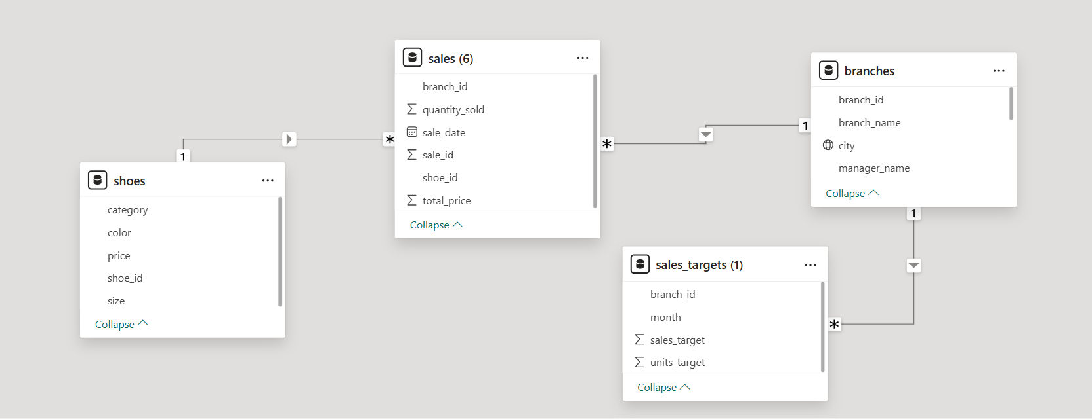
5.Data Model Design
- Schema type : Star Schema
- Fact Table : Sales
- Dimension Tables : Branches , Shoes , Sales_target
Design Advantages :
- Clear separation of fact and dimension data
- Reduced data redundancy through normalization
- Efficient aggregation and filtering
- Optimized performance in Power BI with well-defined relationships

